‘Agavue’ Event Data Sample: Full Dataset
Danyel Fisher. Version of October 20, 2016.
Contact: danyelf@microsoft.com
The original of this dataset can be found at http://eventevent.github.io and https://www.microsoft.com/en-us/research/project/logan-logfile-analysis/
This dataset may be cited as
Danyel Fisher (2016). Agavue Event Data Sample: Full Dataset. Version of October 20, 2016. Microsoft Research. Retrieved from http://eventevent.github.io
The attached files are a sample data release for AgaVue data. They are meant as a representative of real event log features –warts and all. We intend this set to be a useful standard set for users working on visualizations and models of logfiles.
These represent every logged use of Agavue from 2013 through 2016. This dataset consists of 58,581 different sessions; 2,139,847 total events were logged.
Individual visualizations are called “agaves”.
This file roughly follows the EventFlow format, documented at http://www.cs.umd.edu/hcil/eventflow/manual/chapter_start.html
There are some important differences:
- Columns are named in the TSV format in the first line:
  - IP: the IP address of the user; in anonymized format
  - ChartId: The unique chart ID. This could be an effective session marker
  - Date: the date, format is “2013-03-31 01:32:10”
  - ParamsClean: the arguments to the parameters, in the format p1=”600”; p2=”300”
  - Action: the action
  - Version: v1 – v4 are later releases. The first version uses the “p1” format; later versions use named parameters.
- There is no “attribs” file. The information in the attribs can be derived from the IP and ChartID columns
As a note, Agave IDs are unique; every time a user creates a document with an Agave in it, the agave gets a new unique ChartID. When a user opens it in the future, they will get the same ChartID. We also capture the user’s IP address. We also have a DocID field; however, that is not guaranteed to be unique—it is a hash of the document’s name, and thus likely to be “untitled.xlsx”.
We do not have a specific user ID; as such, it is unclear whether a document containing an Agave has been emailed to someone else.

Origin
The “Agavue” project released a series of applications on the web; users have been downloading and running those visualizations as part of an Excel or Access document since their release. The application feeds back updates, called with an HTTP GET request, to the server.
You can find documentation of the user side of these experiences at the project webpage:
https://www.microsoft.com/en-us/research/project/microsoft-research-data-visualization-apps-for-office/
Since “GET” is being used as a logging mechanism:
- Events are not precise to more than a second.
- Some events are known to be out of order if the packets got switched in traffic
- Some logs may be truncated, due to client or server issues.
In general, the logs are meant to preserve privacy while allowing us to track basic usage.

The Apps
These apps were run as visualizations embedded in a sheet of Excel. A single sheet of Excel can contain more than one visualization.
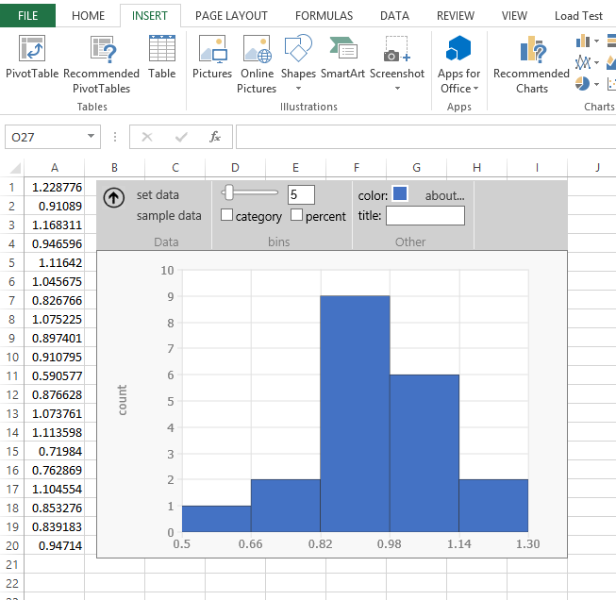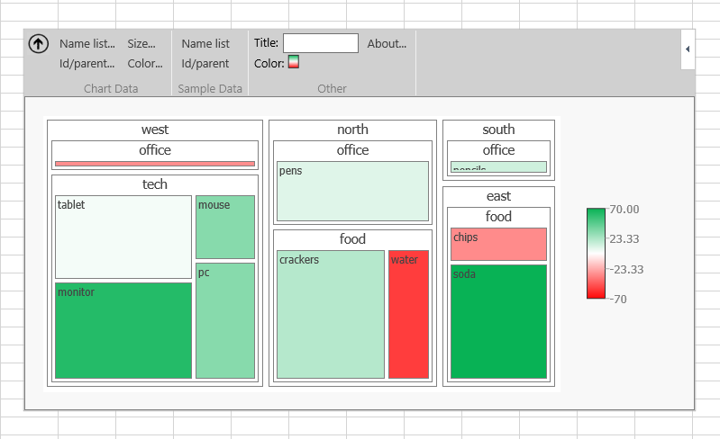
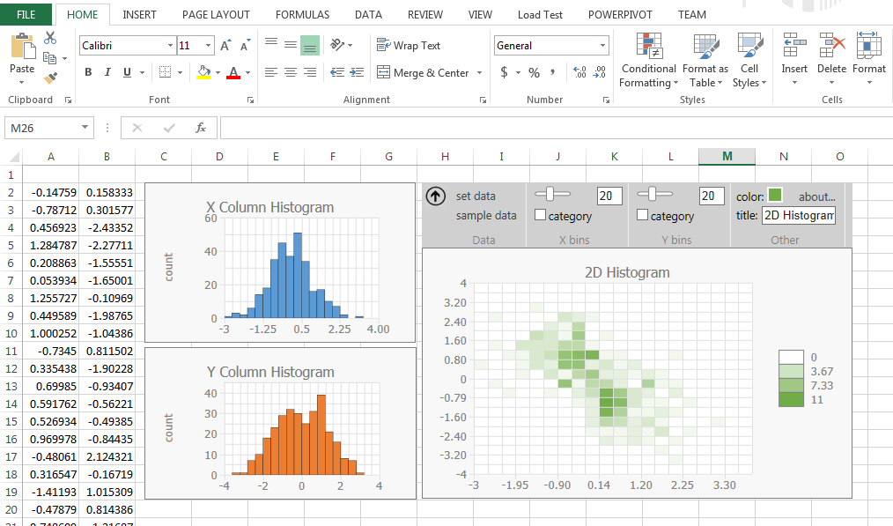
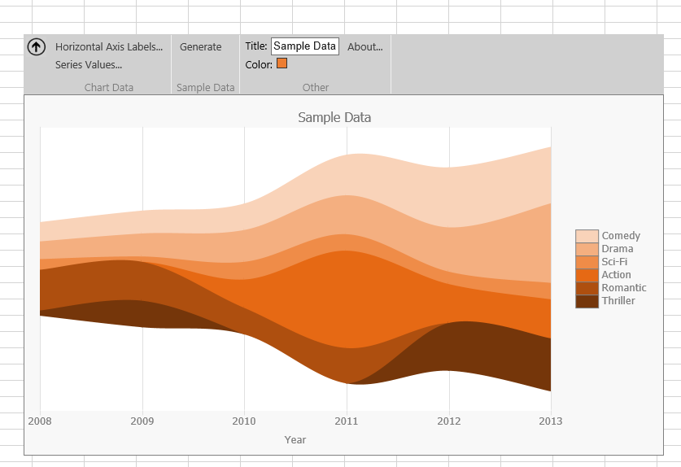

The State Machine
Roughly, a session looks like this:

A user selects data, which creates a data binding between that data and the visualization. The system visualizes their data (or throws an error message); the user manipulates the visualization.

Initialization
appInit( chartName, machineId, docId) | Initiates the applet with the given chartType on this unique machine and in this document. (Both are hashed). Note that many documents are named “untitled document” when created, so the docId – which is a hash of the title – might not be particularly helpful.

Data Binding & Create a Visual
btSetData() | User presses “set data”; this triggers a bindFromPrompt
create( binding ) | Create a new visualization, with this binding. (xBinding = x Axis; yBinding = y Axis; etc)
load (binding) / setData ( binding ) | Notification that the sheet’s underlying data has changed on this binding. setData was what this was called in V1. Triggers a readBoundData
bindFromPrompt() | Data has been bound because the user has requested it (as opposed to loaded). This triggers a readBoundData if successful
readBoundData( colName, format?, rowCount, isCategorical?, min?, max?, seriesCount?) | Read in data from binding. Format is variable depending on which chart type this is.  Colname: what data does this column correspond to?  Format: In a treemap, data can be entered as either nameList or idParent  rowCount: How many rows of data?  Min: smallest value in the dataset  Max: the largest value in the dataset  seriesCount: for a streamgraph, how many series?
treeStats(rootCount, leaveCount, maxDepth, nameColCount, namesWithBlanks) | Statistics about the TreeMap that was just requested, executed after a readBoundData

Adjust the Visual

btColor(isShowingPalette) / pickedColor( color ) / closeColorPicker() | Open color palette; set the color for the visualization; close the color picker
cbCategory(isChecked) | User presses the checkbox “Categorical” to toggle a histogram from categorical to numerical
cbPercent(isChecked) | User presses the checkbox “Percentage” to toggle a histogram from showing counts to showing a percentage
hasColumnHeadersToggle (value) | Does the data have column headers?
resize (width, height) | Automatically triggered at start, or user has manually resized the space
setStackType ( value ) | For lineChart, decides on a drawing type
setTitle (length ) | Sets the title of the chart. Length is the length of the name in characters
Slider( value ); xSlider (value); ySlider (value) | Fired when the user changes the number of buckets on the histogram (or the X and Y sliders on a 2D histogram)
tbBins (value); xTbBins (value); yTbBins (value) | After the slider has stopped, this event shows the number of bins on a histogram (or the X and Y bin counts on a 2D histogram)
toolTip (id) | The user hovers over the control id, and a tooltip appears

UI
These are functions that describe interactions with the system
error(msg) / closeErrorBox() | Show an error message; close the modal box
warning (message) | Shows a warning message
aboutBox() / closeAboutBox() | Shows an informational message; close the modal box
writeSampleData (); writeSampleData2 () | Writes a set of sample data to the sheet. Histogram and 2D Histogram toggle through several different sets of data. Treemap has sample data in Name-Value form (“writeSampleData”) and ID-Parent form (“writeSampleData2”)
toolBarToggle (value) | Shows or hides the toolbar

Let’s Read A Session

Events Table
Guid1004 | appInit | 7/8/2015 17:56:48 |  | chartName=treemap; machineId=machineId_1436375531310_0.04533913009629037; docId=docId_kDFiHl37xmhx1WzAwnLn4KckxzpsVtiWhkvHuDctXjc^
Guid1004 | create | 7/8/2015 17:56:48 |  | bindingName=colorBindingId
Guid1004 | create | 7/8/2015 17:56:48 |  | bindingName=primaryBinding
Guid1004 | create | 7/8/2015 17:56:48 |  | bindingName=sizeBindingId
Guid1004 | resize | 7/8/2015 17:56:48 |  | width=800; height=600
Guid1004 | resize | 7/8/2015 17:56:48 |  | width=800; height=600
Guid1004 | treeStats | 7/8/2015 17:56:48 |  | rootCount=0; leaveCount=0; maxDepth=0; nameColCount=0; namesWithBlanks=0
Guid1004 | bindFromPrompt | 7/8/2015 17:56:56
Guid1004 | readBoundData | 7/8/2015 17:56:56 |  | colName=nodes; format=nameList; rowCount=443
Guid1004 | treeStats | 7/8/2015 17:56:58 |  | rootCount=8; leaveCount=443; maxDepth=2; nameColCount=2; namesWithBlanks=0
Guid1004 | readBoundData | 7/8/2015 17:57:13 |  | colName=size; rowCount=443; isCategorical=false; min=1; max=1242
Guid1004 | readBoundData | 7/8/2015 17:57:27 |  | colName=color; rowCount=443; isCategorical=false; min=0; max=0
Guid1004 | warning | 7/8/2015 17:57:27 |  | msg=Warning:%201%20or%20more%20non-numeric%20values%20were%20converted%20to%200.
Guid1004 | closeErrorBox | 7/8/2015 17:57:32
Guid1004 | btColor | 7/8/2015 17:57:34 |  | isShowingPalette=false
Guid1004 | pickedColor | 7/8/2015 17:57:34 |  | color=rgb(237,%20125,%2049)
Guid1004 | pickedColor | 7/8/2015 17:57:40 |  | color=rgb(165,%20165,%20165)
Guid1004 | pickedColor | 7/8/2015 17:57:42 |  | color=rgb(68,%20114,%20196)
Guid1004 | toolTip | 7/8/2015 17:57:44 |  | id=toolBar
Guid1004 | toolTip | 7/8/2015 17:57:49 |  | id=btColorCol

Attributes Table
Guid1004 | anonIP | ip539
Guid1004 | ChartId | chartId_1436378208885_0.8642284872660698
Guid1004 | vers | v4

A user reloads a chart – we know it’s a reload because there’s an existing series of create operations. The system gets started up. The existing chart has no data, though: the treestats says that it’s got 0 roots.
The user clicks “read data” and binds 443 rows to the nodes column. This makes a tree with 8 roots, 2 levels, and 443 leaves. The user binds in a Size column, with sizes ranging from 1 to 1242; and then a color column. The color column was probably text; they get an error message.
They play with color schemes, and then quit. The full session ran two minutes.

Some Additional Notes
- The current dataset takes a combination of an IP address, the version of the software running, and the ChartId together to be a unique ID. ChartId is a globally-unique ID; therefore, the same chart might have occurred across multiple sessions. You can find the ChartId in the Attributes table.
- The IP address is anonymized; they appear in time order. If two records have the same ip address, their client reported the same IP address – however, that might mean a VPN or a Comcast aggregator.
- Version=v1 of the data named all parameters P1, P2, and so on. It was extremely annoying to parse; as such, parameters are more correctly named as of V2.

Some Sample Analysis Tasks
Basic Usage
How many different visualizations have been created? Of what sorts?
Is there a change in interest over time?

Sample Data
How many of our instances started with inserting sample data?
How often did people then modify it, and still have a successful visualization?
Did users who had used sample data have a better success rate at making the visualization work?

Creation
How many attempts did it take to get a visualization rather than an error message?
How many people gave up?

Reuse
How many instances were reloaded?
How many instances were opened in a different document ID than the original? Different system ID than the original?

Resize
Can we come to some ideas about what the right size of a visual is based on the visualization, amount of data, and so on?

Errors
For each different error, what happens immediately before that?
What visualization type drives each error?
What data shape goes with each error?

Data Shape
How much non-sample data are people looking at?

